Изнаирова Анастасия Владимировна
Учитель английского языка
МБОУ СОШ-ДС №6 г. Симферополь

Brain-Ring
Класс: 10-11
Цели: формирование межпредметной коммуникативной компетенции
Задачи:
образовательные:
- закрепление полученных знаний, применение их в нестандартных ситуациях;
- формирование учебно-познавательной и социокультурной компетенции учеников;
- формирование коммуникативных навыков говорения;
- расширение межпредметных знаний, кругозора учащихся
развивающие:
- развитие навыков речевой культуры, аналитических способностей, памяти, логического мышления;
- развитие внимания, воображения учащихся;
- развитие творческих талантов учащихся;
- развитие потребности дальнейшего самообразования в области иностранных языков
воспитательные:
- формирование доброжелательного отношения и толерантности к культуре и традициям представителей других стран;
- формирование познавательных интересов учащихся, мотивации к изучению иностранных языков;
- формирование навыков самоконтроля, навыков групповой деятельности, сотрудничества в обстановке, взаимопонимания в отношении к своим сверстникам;
- формирование культуры общения и поведения;
Оборудование: компьютер, телевизор, презентация, карточки с заданиями, раздаточный материал, песочные часы.
Тип урока: мероприятие-викторина
Методы обучения:
- метод эмоционального стимулирования;
- метод иллюстраций и самоконтроля;
- дедуктивный и практический методы;
- викторина;
- репродуктивный;
- частично-поисковый;
Формы организации: командная игра, групповая

Ход мероприятия
Good morning everybody! We’re glad to welcome you to our competition “Brain Ring”! Brain Ring is an intellectual game where you answer questions, do different tasks racking your brains.
Let’s form two teams. You should choose your captain. Each captain must introduce his or her team by saying its name. … Thank you, they were quite original.
So today we have five categories: 1. English World, 2. Geography, 3. Personalities, 4. Literature, 5. Story Time.
Each category has different number of questions and tasks. If your answer is correct you get a point, if your answer is incorrect the other team has a chance to give an answer.
I’d like you to pay attention to the buttons on your tables. If you know the answer or at least think that you know the answer, press the button.
Are you ready to start?
Warm-up “Let’s choose a Leader”
Of course we start our competition with Brainstorming! You’ll see three puzzles with an encrypted proverbs (saying). The task of each team is to solve them as quick as possible and of course explain their meaning with examples if possible. This way we’ll get the team which will choose the category for the next round. So be attentive, please.
Puzzles.
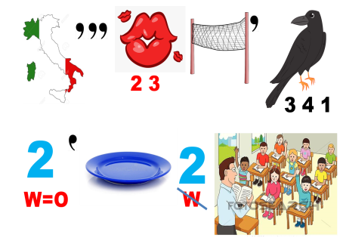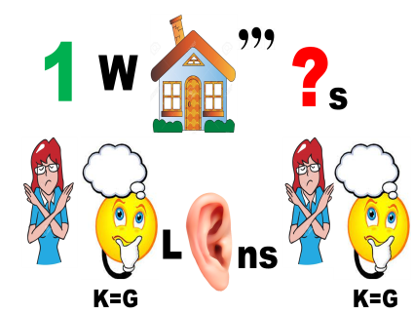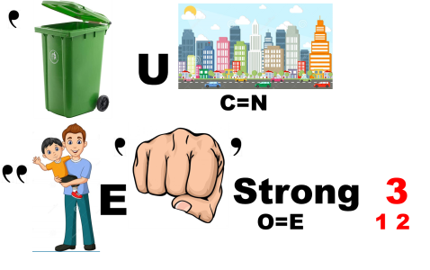
1. It is never too late to learn
2. One who questions nothing, learns nothing
3. In unity, there is strength
Well done! Now we are ready to our main part! Please choose the category.
Task 1. English World
In this task you should answer the questions about English-speaking countries. The captain of the team…please choose the number from 1 to 12.
1. Give the full name of the UK (The United Kingdom of Great Britain and Northern Ireland)
2. List the parts of the UK (England, Northern Ireland, Scotland and Wales)
3. What city has the nickname "Big Apple"?. (New York)
4. What is the currency in Britain? (pounds)
5. What is an unofficial name of the UK flag? (The Union Jack)
6. Who was the first president of the United States? (George Washington)
7. What flower is a symbol of the Northern Ireland? (Shamrock)
8. What do Americans celebrate on the 4th of July? (Independence Day)
9. Name the official residence of the Queen in London. (Buckingham palace)
10. Look at the screen and name the sight (The Mount of Founding Fathers. Mount Rushmore pays patriotic tribute to four United States presidents—George Washington, Thomas Jefferson, Theodore Roosevelt, and Abraham Lincoln—with 60-foot-tall faces carved into a mountainside in the Black Hills of South Dakota.) (приложение 1)
11. What do children usually say on Halloween? (trick or treat)
12. How many states are there in the USA? (50)
Thank you very much for you answers. Now the leader is the team… I believe you have become the real expert of English-speaking countries. But we continue our little competition. Team.. choose the next category.
Task 2 Geography
In this task you should give correct answers for questions in geography. Be attentive there are some photo-questions where you have to name the place, its location and some interesting information.
1. How many continents are there in the world? List them (There are seven continents: Asia, Africa, North America, South America, Antarctica, Europe, and Australia)
2. How many oceans are there in the world? (4-5 the Atlantic, Pacific, Indian, and Arctic Oceans, the Southern Ocean)
3. What is the second largest country in the world? (Canada)
4. Photo-question (Stonehenge, England) (приложение 2)
5. Photo-question (Mother-land, Volgograd) (приложение 3)
6. What is the highest mountain in Russia? (Mount Elbrus, Caucasus)
7. Photo-question (Shakespeare museum, Stratford-upon-Avon, England) (приложение 4)
8. Which photo depicts Yellowstone National Park? (2) (приложение 5)
9. List seven countries with their capitals.
10. What countries border the United Kingdom? (one land border, and that is on the island of Ireland)
Very good. I am very glad to see that you have such good knowledge in geography. And the team… is the lord of it.
Now the next stage! The Team… it’s your time to choose.
Task 3. Personalities
In this stage you should guess a famous person or people according to the list of associations. But remember you need not only to tell the name but also explain each association. Choose from 1 to 6.
- Abraham Lincoln – sixteenth, luxury vehicle, the tallest, no slavery
- Neil Armstrong – one small step, 20th of July, land, the Earth’s satellite
- Michael Jackson – king, thriller, one of five, moonwalk
- Peter the Great – swamp, Saint Petersburg, beards and moustache
- Edgar Allan Poe – mystery, raven, three letters, in a kingdom by the sea
- The Beatles – Liverpool, yesterday, fashion for long hair, four
It was hard but you have done a good job. I guess we can have a music pause. Let’s listen and sing yellow submarine song. (singing a song) Team … choose the category.
Task 4. Literature
We are going to check whether you good at explanation or not. Your task will be to explain as many titles of books as possible for 1 minute. You are not allowed to use words from the title itself, but you can use names of authors or facts from the plot. Also, you can explain the titles using associations.
    - War and Peace
    - Hamlet
    - Crime and Punishment
    - Anna Karenina
    - Alice in Wonderland
    - Beowulf
    - The Canterbury Tales
    - Harry Potter
    - The lord of rings
    - Fathers and sons
    - Dead Souls
    - Romeo and Juliet
    - The portrait of Dorian Grey
    - Sherlock Holmes
    - The Great Gatsby
    - The old man and the sea
    - Robin Hood
    - The Master and Margarita
    - The Little Prince
    - Fight Club
Let’s count how many correct answers teams gave. And the winner in this round is …
Now you are almost ready to become the kings of Brain-ring! We have one more category. The team… your turn.
Task 5. «Story Time»
And finally the last task. You are going to read a story, then you will choose the card with the name of a person or object of the story through the perception of which you will have to retell the story. Be attentive, do not mention the name you read in your card because your opponent need to guess it. Each team will have 2 cards. You can make up new facts, untold in the story, describe feelings and emotions.
Examples of cards: boat, schoolbag, ship, bridge
Our best congratulations to Team ______ and its captain. They are the winners of the contest. Don’t worry if you are not the first. Only one team can be first. Let me thank all participants of the competition. Thank you very much and good-bye.

Список использованной литературы
- Полупан А. П. English-speaking countries: A cultural reader/ Полупан А. П., Полупан В. Л., Махова В.В.. — X.: Издательская группа «Академия», 2000. — 208с.
- Смирнов Ю. А. Английский язык. Современная Британия. 10—11 классы. Элективный курс: пособие для учащихся общеобразоват. учреждений и шк. с углубл. изучением англ. яз. / Ю. А. Смирнов. — М. : Просвещение, 2012. — 252 с.
- Куриленко Ю.В. 400 тем английского языка/ Ю.В. Куриленко. — Ростов н/д: Удача, 2010. — 608 .

Приложение 1
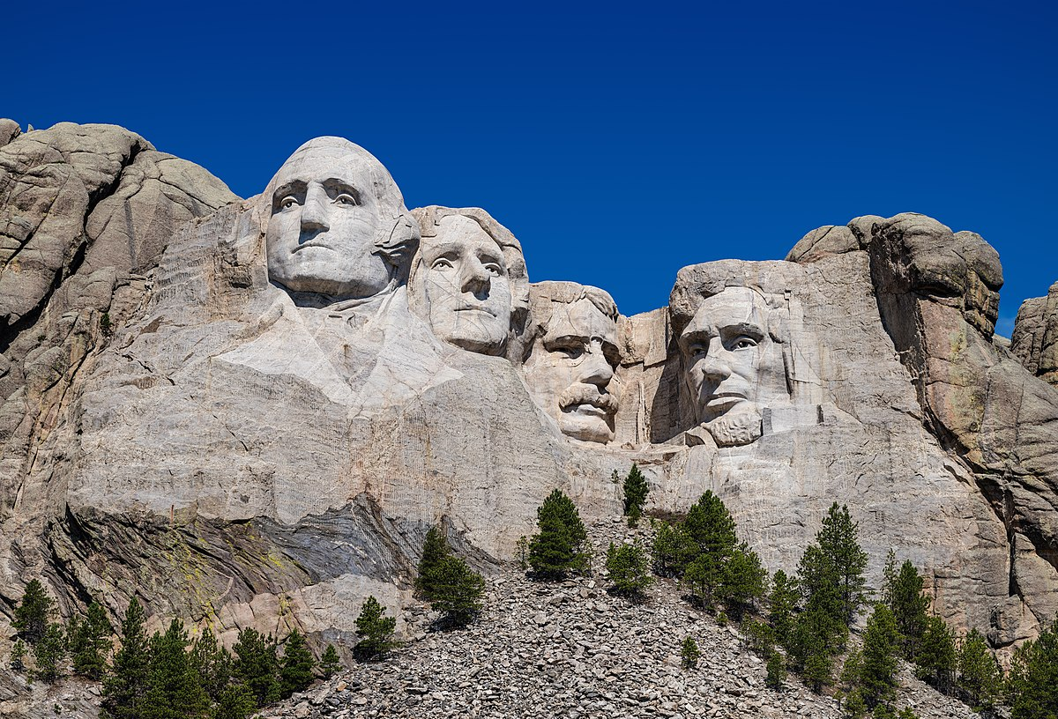
Приложение 2
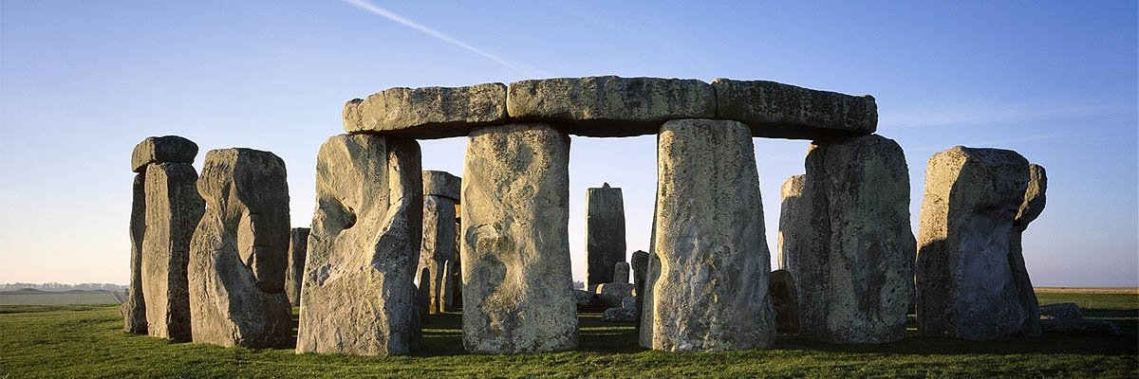

Приложение 3
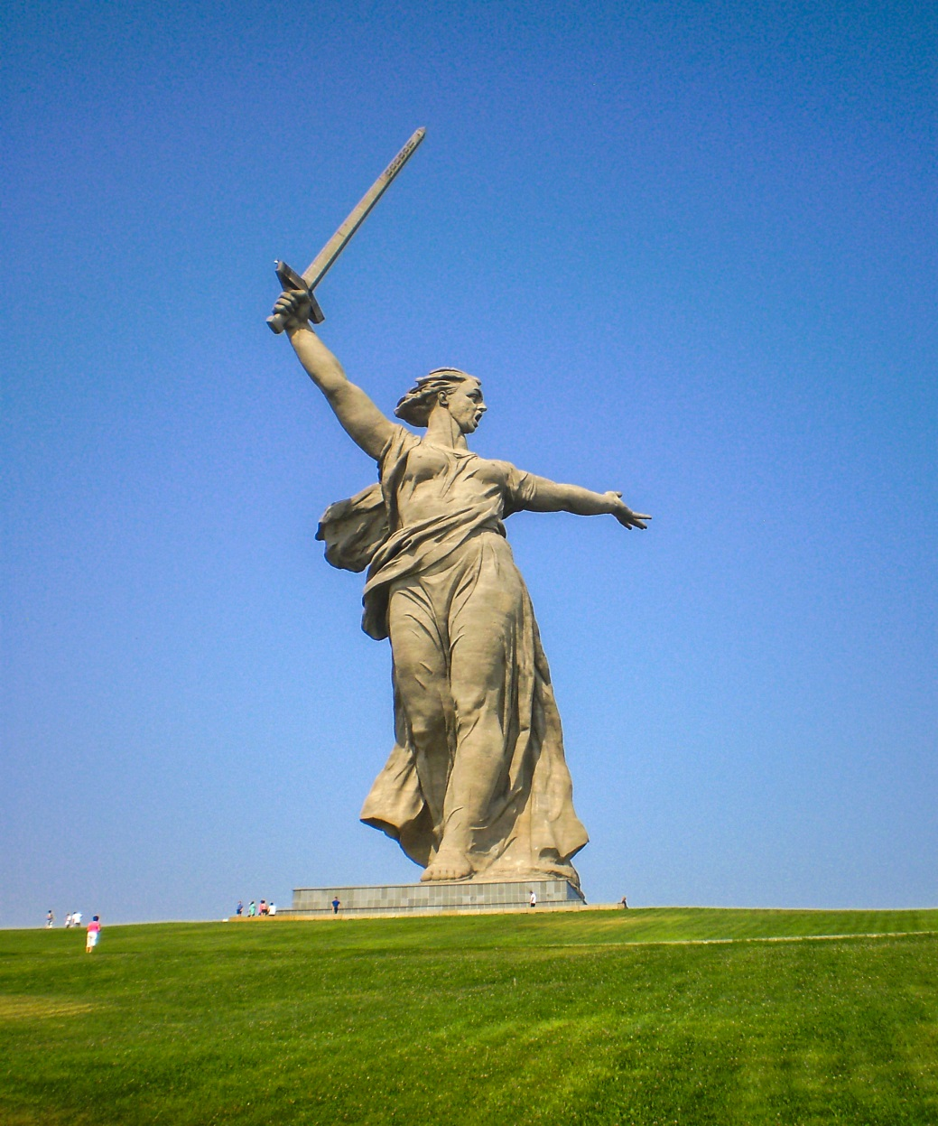

Приложение 4
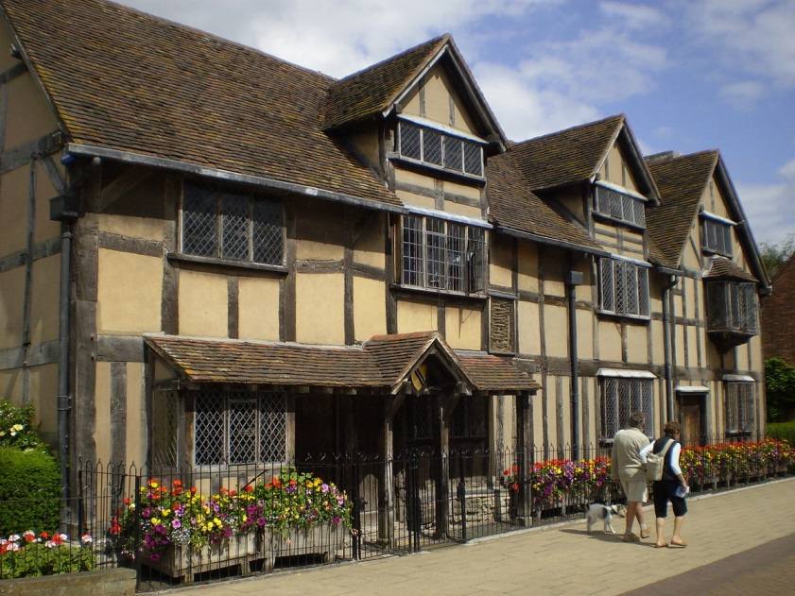
Приложение 5
